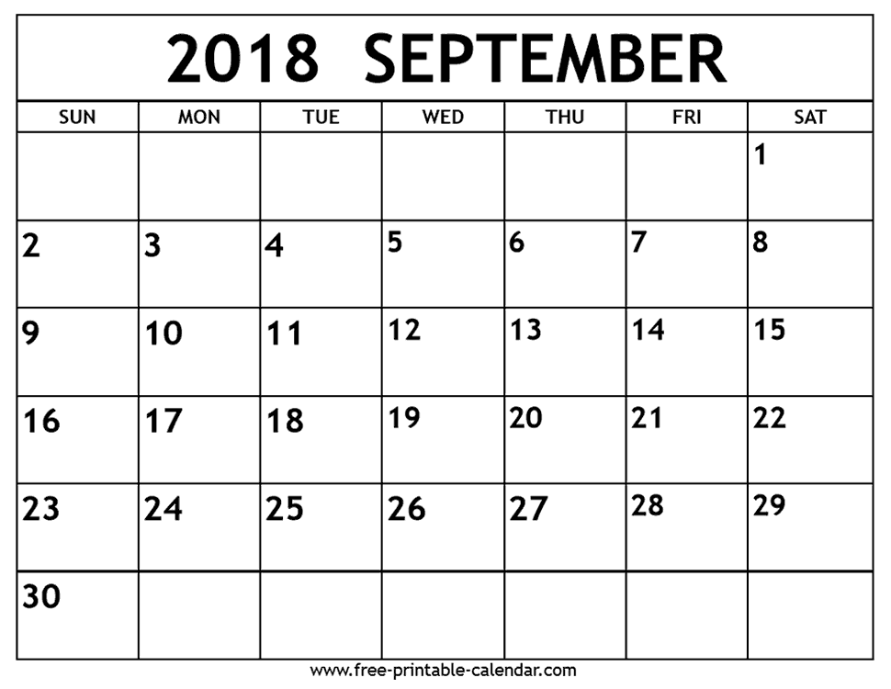
AP & Portfolio Preparation
Calendar

No Class B- Breadth
Critique C- Concentration

AP Due Every 3 Weeks
PP Due Every 6 Classes

Week of Sep 3rd Prof Learn Prof Learn First Day
APD&AP2: Boot Camp Labor Day Half Day Half Day
PP: Boot Camp

Week of Sep 10
APD: Boot Camp Due 9/18
AP2: Boot Camp Due 9/18 Rosh Hashana Summer Work
PP: Boot Camp Due

Week of Sep 17
APD: B1 Best Drawing Due 10/10
AP2: B1 Best Drawing Due 10/10 Boot Camp Yom Kippur AP & PP
P2: RISD Instrument Due 10/1 Due Critique
Concentration Topic Due 9/24
Week of Sep 24
APD: B2Architecture Due 10/10
AP2: B2 Pos/Neg Space Due 10/10 Concentration
P2: RISD Instrument Due 10/1 Topic Due 9/24
B1, B2, C1 Due 10/10

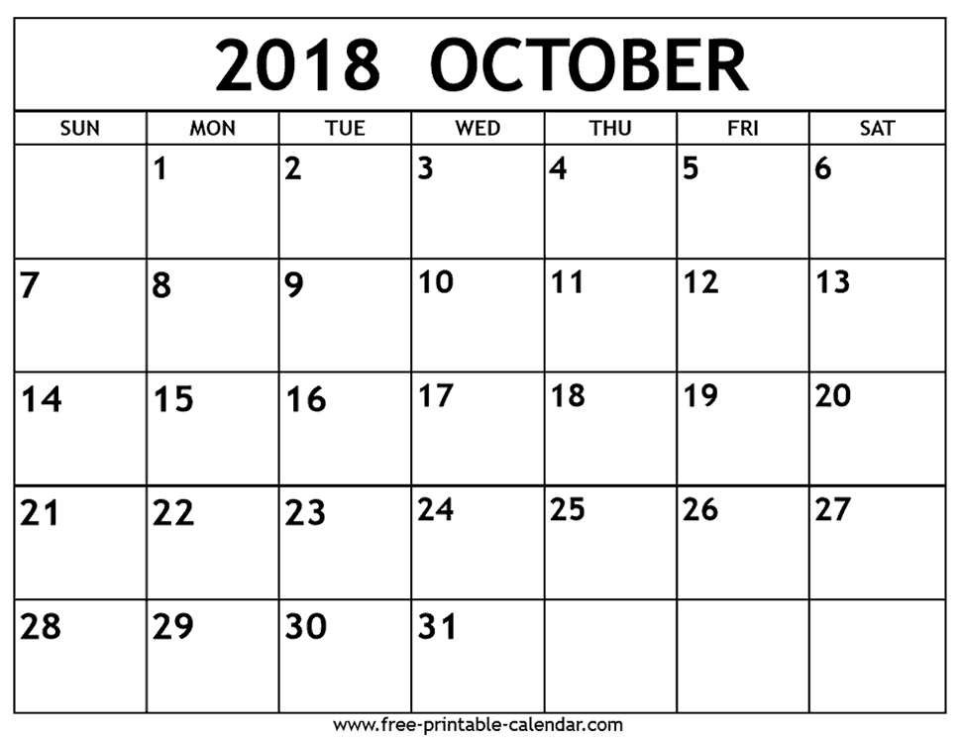

Week of Oct 1-B1, B2, C1 Due 10/10
APD&AP2: C1 Due 10/10
P3: Skeleton Still Life Due 10/12 PPI Due

Week of Oct 8
APD: B3 Reflective Objects Due 10/29 Half Day
AP2: B3 Repetition Due 10/29 Columbus Day B1, B2, C1 Due AP&PP Crit
P3: Skeleton Still Life Due 10/12 PPS-Due

Week of Oct 15
APD&AP2: C2 Due 10/29
P4: Coop Choice # 1 Due 10/24
B3, C2, B4 Due 10/29

Week of Oct 22-
APD: B4 Surrealism Due 10/29
AP2: B4 Layering Due 10/29 PPC1 Due
P4: Coop Choice# 1 Due 10/24

Week of Oct 29 1 2
APD&AP2: C3 Due 11/19
P4: Coop Choice # 2 Due 11/5 B3, C2, B4 Due AP&PP Crit Halloween
C3, B5, C4 Due 11/12

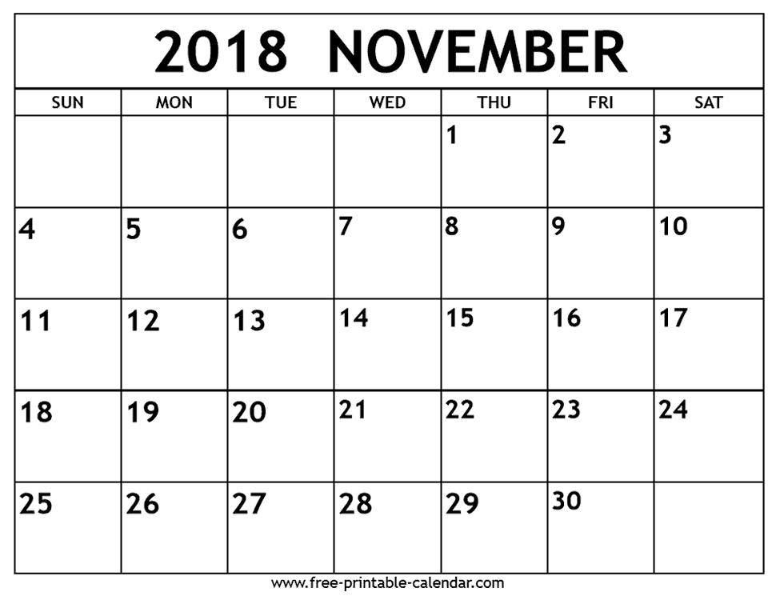
AP & Portfolio Prep
Calendar

Week of Oct 2- C3, B5, C4 Due 11/19
APD&AP2: C3 Due 11/19
P4: Coop Choice # 2 Due 11/5

Week of Nov 5
APD: B5 Color Theory Due 11/19 Professional No School
AP2: B5 Layering Due 11/19 PPC2 Due Day NJEA Conv.
P5: Foreshortening Due 11/19
C3, B5, C4 Due 11/19

Week of Nov 12
APD&AP2: C4 Due 11/19 AP&PP Crit
P5: Foreshortening Due 11/19

Week of Nov 19
APD: B6 Sound Due 12/11 Half Day No School
AP2: B6 Emphasis Due 12/11 C3, B5, C4 Due AP&PP Crit Give Thanks
P6: Threshold Due 12/3 PPF Due
B6, C5, B7 Due 12/11

Week of Nov 26
APD&AP2: C5 Due 12/11 PPT Due
P6: Threshold Due 12/3
B6, C5, B7 Due 12/10

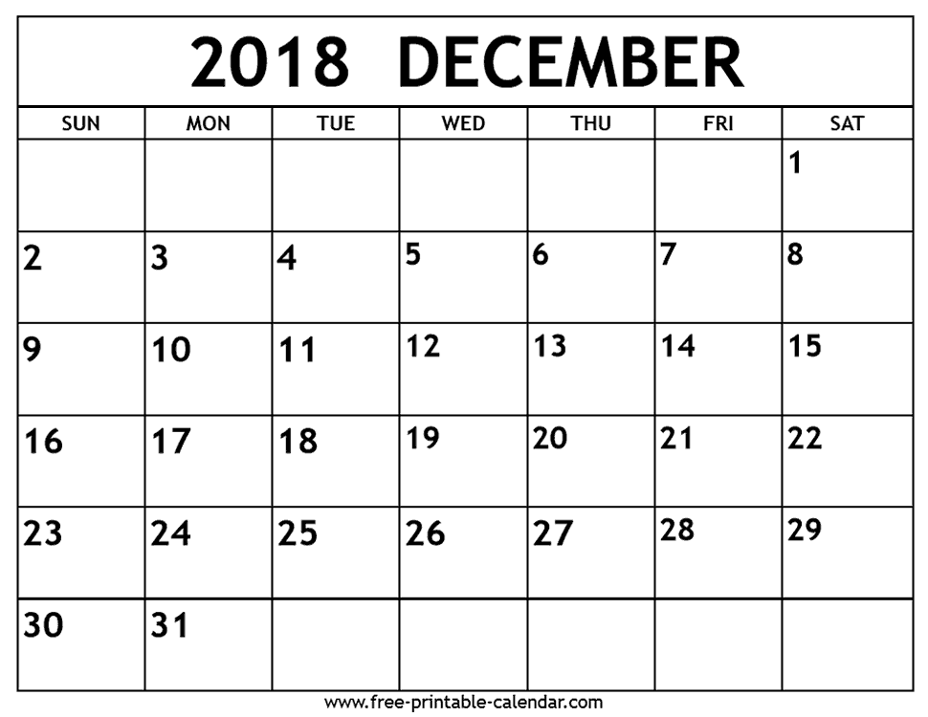

Week of Dec 3
APD: B7 Exp Portrait Due 12/10
AP2: B7 Lyrical Poster Due 12/10 PPT Due
P7: Plastic Due 12/13
B6, C5, B7 Due 12/10
Week of Dec 10
APD&AP2: C6 Due 1/8 B6, C5, B7 Due AP&PP Crit
P7: Plastic Due 12/13 PPP Due

Week of Dec 17
APD: B8 Fairy Tale Due 1/8 Half Day
AP2: B8 Fairy Tale Due 1/8
P8: Fairy/Folk Tale Due 1/3

Week of Dec 24
No Assignment W I N T E R B R E A K
C6, B8, B9 Due 1/8

