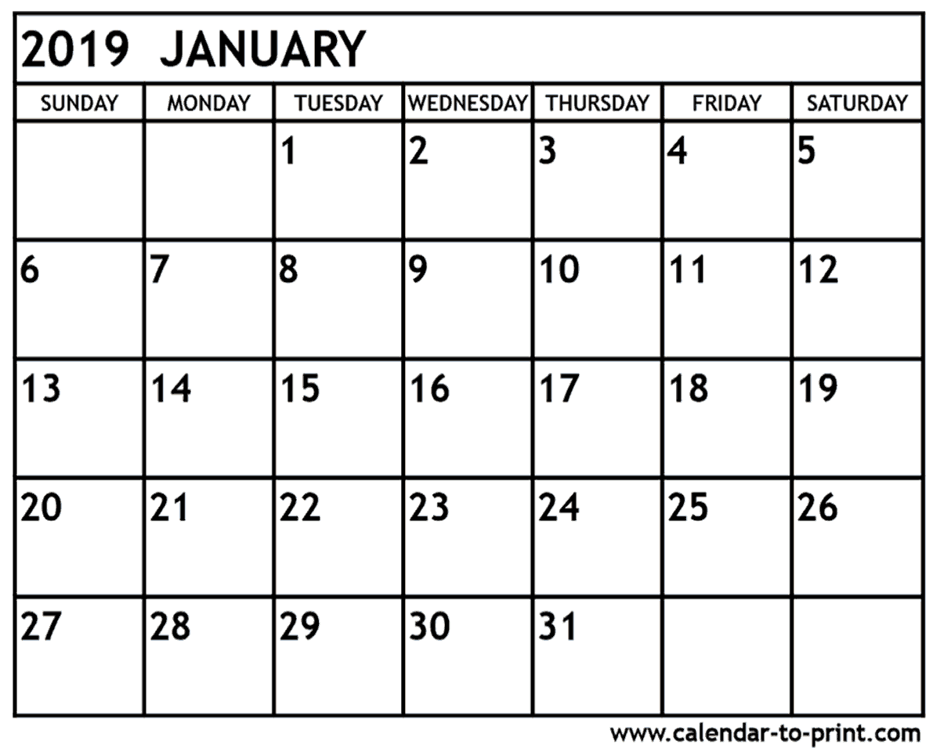
AP & Portfolio Prep
Calendar

Week of Dec 31 New Year’s New Year’s
APD: B9 Hands Due 1/8 Eve Day PPF Due
AP2: B9 Hands Due 1/8
P8: Fairy/Folk Tale Due 1/3

Week of Jan 7
APD& AP2: C7 Due 1/28 C6, B8, B9 Due
P9: Hands Due 1/15 AP&PP Crit

Week of Jan 14
APD: B10 Cardboard Due 1/28
AP2: B10 Cardboard Due 1/28 PPH Due
P9: Hands Due 1/15

Week of Jan 21 MLK
APD& AP2: C8 Due 1/28 Day
P10: Coop Choice2 #1 Due 1/28 Half Day
C7, B10, C8 Due 1/28

Week of Jan 28
APD&AP2: C9 Due 2/19 PPC#1 Due
P10: Coop Choice2 #2 Due 2/7 C7, B10, C8
C9, B11, C10 Due 1/19 Due

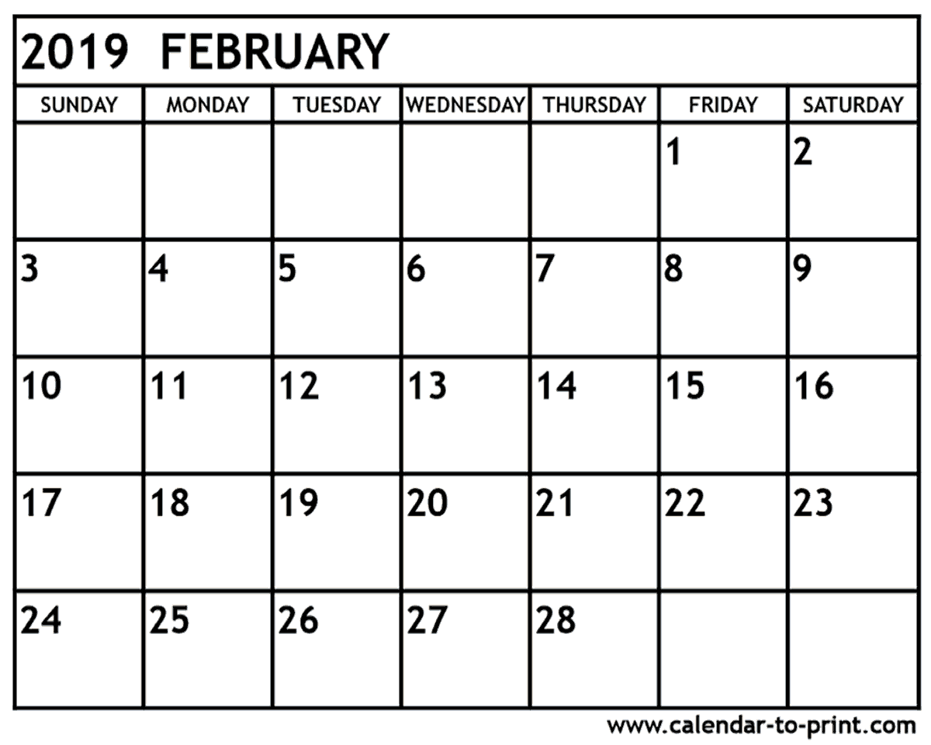

AP&PP Crit

Week of Feb 4
APD: B11 Clothing Due 2/19 PPC#2 Due
AP2: B11 Self Port Due 2/19
PP: Coop Choice2 #2 Due 2/7
C9, B11, C10 Due 2/19

Week of Feb 11
APD& AP2: C 10 Due 2/19 Half Day
PP: Cut Paper Due 2/20

Week of Feb 18
APD: B12 High Cont Due 3/12
AP2: B12 High Cont Due 3/12 C9, B11, C10
PP: Cut Paper Due 2/20 President’s Due PPCP Due AP&PP Crit
Day
Week of Feb 25
APD&AP2: C 11 Due 3/12
PP: Chalk Pastel Due 3/4
B12, C11, C12 Due 3/12
Draft Artist Statement Due 3/1
Artwork Inv. Draft Due 3/8

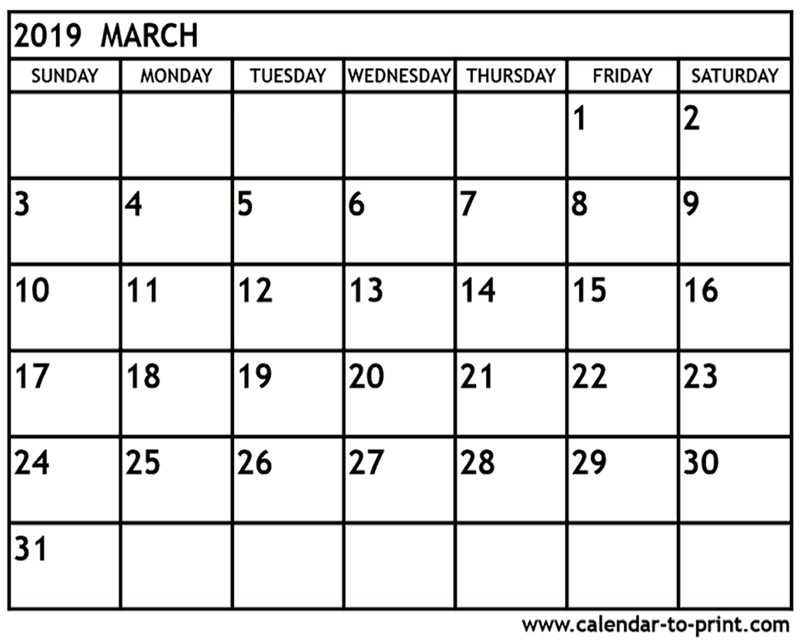
AP & Portfolio Prep
Calendar

Week of Feb 25
APD&AP2: C11 Due 3/12
PP: Collect Due 3/12
Artwork Inv. Draft Due 3/8
Week of Mar 4
APD&AP2: C 12 Due 3/12 AP Artwork
PP: RISD Collect Due 3/14 PPCh Due Inventory Due

Week of Mar11 B12,
AP: B 13 Choice Due 4/1 C11, C12 Prof
PP: RISD Collect Due 3/14 Due PPCoDue Day
AP&PP Crit
Week of Mar 18 Due
AP: C 13 Due 4/1
PP: Text and Design Due 3/27 Upload Art to AP Website

Week of Mar 25
AP: Choice/Upload 1Due 4/1
PP: Text and Design Due 3/27 PPT&DDue
B13, C13, Choice 1 Due 4/1

Upload Artwork last two weeks of March
Artwork Digital Upload Due April 12
Artist Statement Due to Mrs. Medio to edit 4/15
Artist Statement Upload Due 4/29
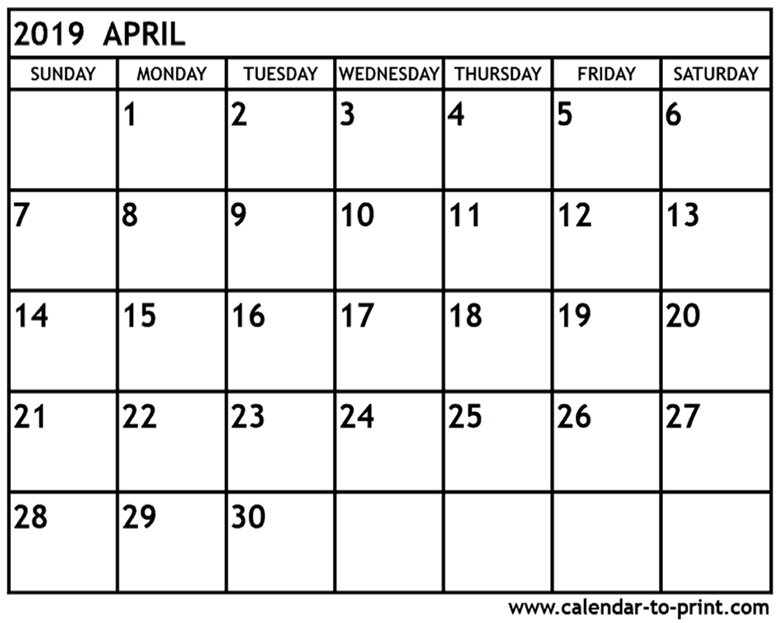

Week of April 1
AP: Choice Upload 2 B13, C13,
PP: Every Day Task Due 4/8 Choice 1 Due AP&PP Crit
Digital Art Upload Due 4/12

Week of Apr 8
AP: Art Upload Due 4/12 Choice 2 Due Digital
PP: Bicycle Due 4/18 PPEDT Due Upload Due

Week of Apr 15
AP: Statement Upload Due 4/29 PPB Due
PP: Bicycle Due 4/18 Artist State No School
Half Day Break Begins

Week of Apr 22
No Assignment
S P R I N G
B R E A K

Week of Apr 29 MAY 1 2 3 4
AP: Statement Upload Due 4/29 Artist State
PP: Self Portrait Due 5/8 Upload Due
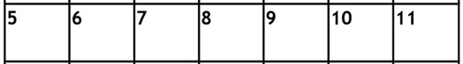
PPSP Due

