Hands
Create Artwork inspired by the theme of Hands. Open media. Make sure that you are making a conscious choice as to what technique, skill, medium, element, or principle you would want to display to a portfolio reviewer.
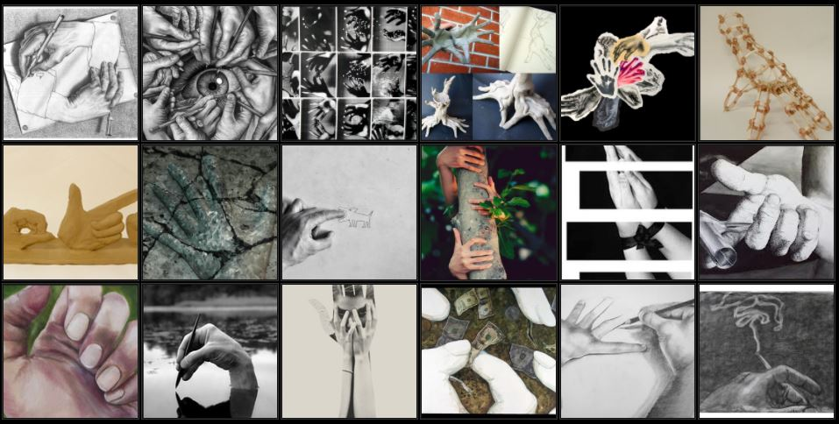
Brainstorming Ideas:
- Look at hands…. Your own, your parents, friends, etc.
- Look at various artist examples of hand drawings and paintings.
- Think about all that hands can do…. Create, draw, cook, etc.
- What do your hands say about you? What does your grandmother or grandfather’s hands say about her or him?
- Choose a story of hands and create a composition around that idea.
- You can focus only on hands or you can include the body or other elements to aid in the telling of your story.
- I recommend drawing from life but if needed, take several pictures to help you with your idea and the composition.
- You must include at least one pair of hands but you are not limited and can include other hands if you wish.
- Think about utilizing the space but be sure the hands remain the focal point of the composition.

