RISD HOME TEST Example- Bicycle
A home test is a test required by some art schools as part of the application process. RISD asks students to complete a series of specific artworks at home to submit to admissions for evaluation. RISD is a very competitive school. To gain admissions you must put a lot of effort and thought into the home test. Mrs. Medio has modified this example to suit our purposes.
We consider drawing to be as much about process as presentation and encourage you to consider your drawing submissions as exercises in experimental thinking and risk-taking more than as final presentations or examples of technical proficiency. We do not value any particular style of drawing more than another, so feel free to explore the full range of possible expression in your drawings. We are looking for work that reveals a distinct point of view.
Drawing | Observe and draw a bicycle
- Submit a drawing sample, completed on a sheet of white paper measuring 11” x 14” or 16” x 20”
- This drawing must be done using either graphite pencil or charcoal.
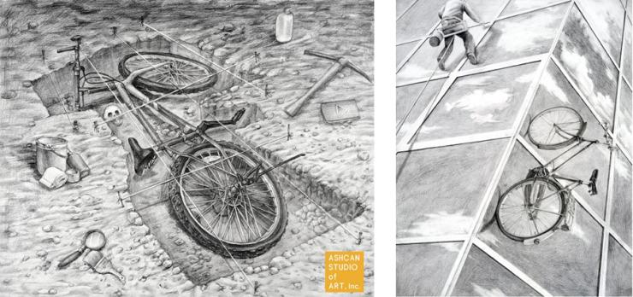

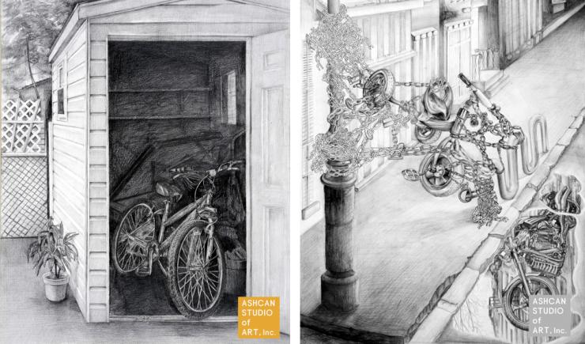
You may approach this drawing in any way you wish. Other than the stated requirements related to paper size, subject and medium – everything and anything else – are up to you. Using photographs as a source for your drawings, however, is not recommended.

