Chalk Pastel Landscape
Create Artwork inspired by the theme of the landscape. Students should use new media or approach the media in a new way. Mrs. Medio will demonstrate the chalk pastel painting technique taught by South Jersey artist Renee Leopardi prior to this assignment.
Students should prepare for this assignment by printing photographs they have taken of landscapes and by viewing the image examples on the website below. Bring a couple of simple images to choose from.
http://reneeleopardi.com/paintings.html
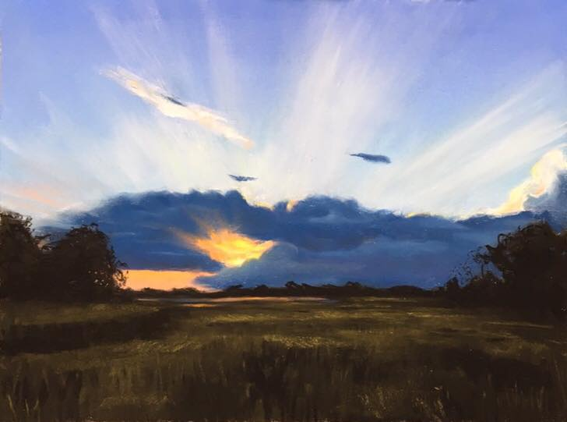
Mrs. Medio’s pastel painting of Fortescue, NJ

